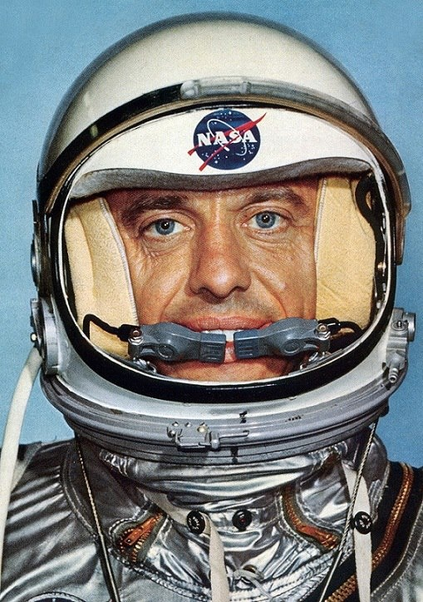
Why do astronauts need helmets?

- For protection
- To communicate with Mission Control
- To keep oxygen at the right pressure around the astronaut’s head

Visor
Materials:
Pre-cut paper plate
Pipe-cleaner
Popsicle stick
Tape
Art materials to decorate your helmet.
Astronaut Alan B. Shepard became the first American in Space in 1961. (NASA)

Microphones
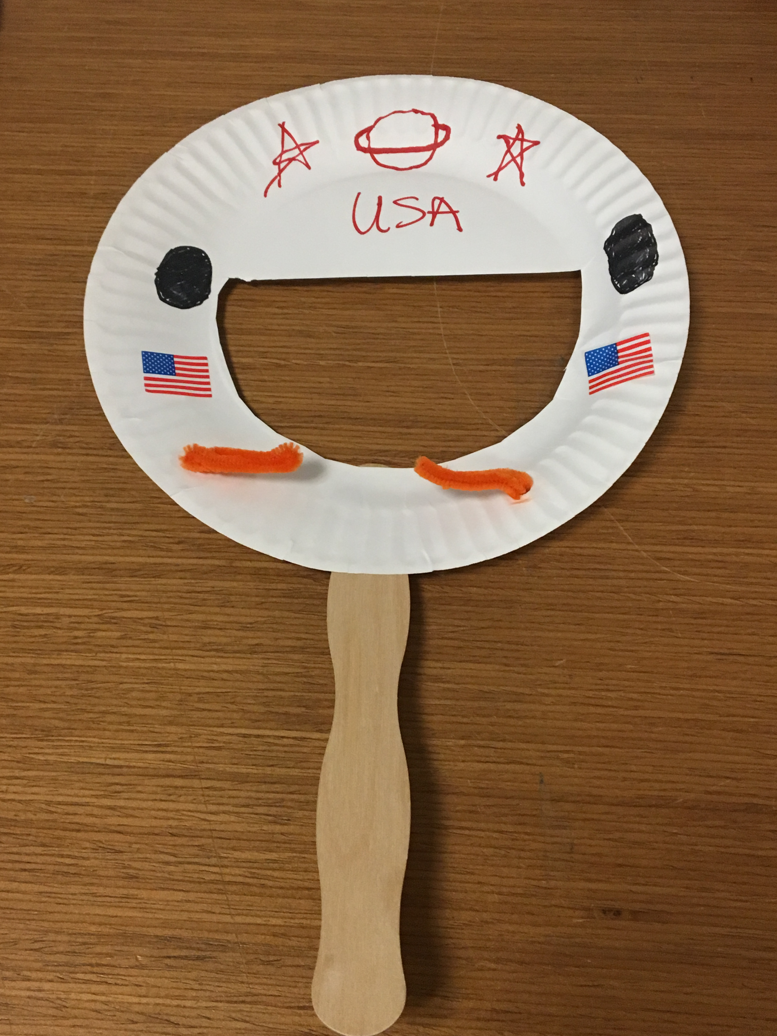
How do I make an Astronaut Helmet?

- Cut across the middle of the plate to make a hole for your face. Now the top half of the plate is your visor.

- Draw circles for hinges for the visor on either side of your helmet. Decorate it with the art materials.

- Ask an adult to punch a hole on either side of the plate. Add your microphones. Push the ends of the pipe-cleaner through both holes. Bend the pipe-cleaner in front of the helmet to form two microphones.

- Tape the popsicle stick to the back of the helmet.

- Visit the Space Exhibit (map #9) and watch Astronaut Alan Shepard on the video as he uses his microphone to talk to Mission Control back on Earth! Explore the real space craft that carried Astronaut Shepard on his historic flight.

