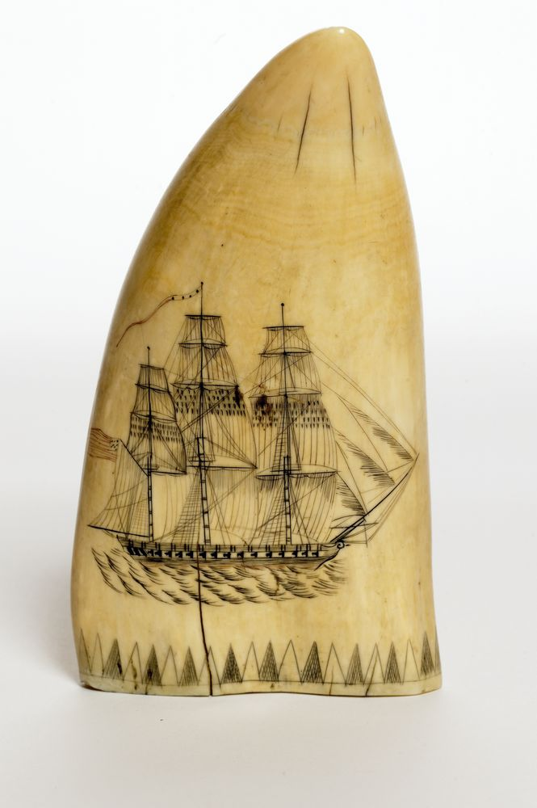
What is scrimshaw?

Scrimshaw—whale teeth, whale bone, and animal tusks carved with intricate designs and pictures—is a truly American art form. It probably originated with certain Native American cultures, and was developed and refined by sailors on whaling ships in the 18th- and 19th-centuries. During whaling voyages, which often took years, many whalers took up hobbies to pass the time. Making scrimshaw was practiced by whalers, navy and merchant seamen while aboard a ship.

President Kennedy had a personal collection of scrimshaw. He even kept some pieces of scrimshaw in the White House's Oval Office.

Design a Piece of Scrimshaw
Materials:
- Blue paper card
- Bar of soap
- Carving toothpick
- Q-tip
- Paper towels
- Plastic bag
- Black shoe polish
- Clean wipes
Directions:
- Make a drawing on the blue card to practice.
- Use your toothpick to carve your drawing onto the soap. Trace your design 2-3 times so it is well defined.
- Ask the table captain for shoe polish and use a Q-tip to rub shoe polish on the soap over the design. Make sure to get the shoe polish in the design lines.
- Use clean paper towels to wipe off all the extra shoe polish.
- Place your “scrimshaw” in a plastic bag.
- Wipe your hands and your work area clean.

