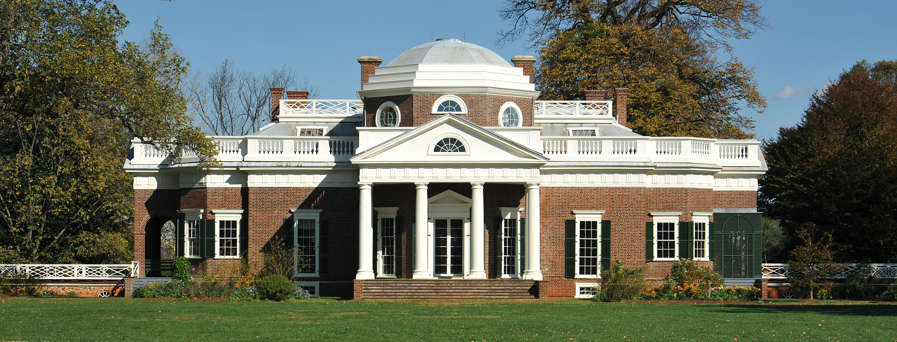
Monticello from the west lawn, Charlottesville, Virginia.

President Jefferson was a man of many talents, including architectural design. At the age of 26, he inherited land from his father and began designing his plantation home, Monticello. He maintained Monticello as his primary home and continued to expand it during the course of 40 years. Distinctive neoclassical features include the dramatic columns and a balance of simple geometric shapes such as the various windows.

While Jefferson designed Monticello, he did not build it himself. Jefferson hired local craftsmen and their apprentices to construct the building. John Hemmings, one of the many enslaved individuals Jefferson owned, was trained by a workman and became a skilled carpenter in the process of making Jefferson’s grand designs a physical reality. Monticello is now a National Historic Site visited by people from all over the world.

Decorate Monticello and make it your own by using the outlines of Jefferson’s original architectural designs using line sculpture art techniques.

What is line sculpture?
A piece of art made by reshaping lines to create a sculpture.

How do I create a line sculpture design?
- Use the outline of Jefferson’s Monticello. You can outline any details or additions to make it your own.

- Arrange and fill in the outline by gluing down the colored wax-yarn to the outline and create your own architectural masterpiece!

