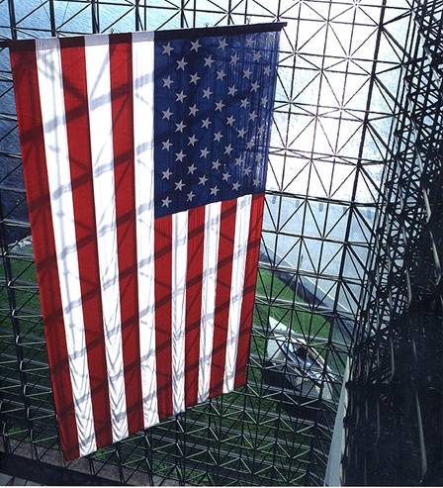
President Kennedy didn’t want a statue or painting of himself in the Library and Museum. The flag is the architect’s way of referencing President Kennedy. It is a symbol that reminds us of him and of the office of the presidency.

The American flag flies 24 hours a day on the White House grounds.

The American flag has flown on the North Pole, on top of Mount Everest, and on the moon, among other places.
The colors have meaning:
- Red symbolizes hardiness and valor.
- White symbolizes purity and innocence.
- Blue represents vigilance, perseverance, and justice.

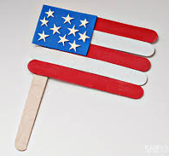
Materials:
- 4 red popsicle sticks
- 3 white popsicle sticks
- 1 large wavy stick
- Star stickers
- Blue square
- Clear tape
Directions:
  - Stack popsicle sticks next to each other, alternating the red and white.
  - Use a piece of clear tape to keep the popsicle sticks in place and for added support. Then turn it over so the tape is on the back.
  - Glue the popsicle sticks to the top corner of the large wavy stick (make sure the clear tape is on the back).
  - Place the star stickers onto the blue square.
  - Add the stick-on magnet to the back of the wavy stick.
  - Glue the blue square with the star stickers to the top corner of the red and white sticks.

